# CHAPTER ONE

# INTRODUCTION

## 1.1 BACKGROUND OF THE STUDY

Gombe state transport service (Gombe line) is a government parastatal owned by Gombe State government, it is the major source of transporting of people and goods from Gombe to other states within the nation like Bauchi, Maiduguri, Yobe, Taraba, Yola,Kano, Abuja, Lagos, etc. providing the best services compared to other transport industries.Usually they do paper works for keeping their customer’s details and booking records. If any customer needs to reserve or book seat he or she needs to make a call or walk in to their counter which is considered as wasting their valuable time. Sometimes the phone line is also busy and customers find it difficult to make a reservation.

Al-hijaj (2013) The utilization of transport is an expensive developing business in Cities and different nations, the manual utilization of bus reservation is extremely strenuous furthermore devours a considerable amount of time. For this reason, a proficient system is proposed in this project to facilitate the issue of transport reservation amongst people in a particular city or place. Bus ticket booking during the offline era posed various difficulties to the customers as well as the bus operators. Offline ticket booking reduced the scope of customers to choose different options based on their travel criterion. The bus operators were also finding it difficult to monitor their bus seat filling information. Many small and medium bus service organizations do not have their own online bus ticket booking system. Online Bus Booking system is a total internet ticketing operation offering the benefit of total in-house management of bus schedules, ticket bookings, ticket sales, report generation, and other business functions associated with ticket sales.

Alter (2013) The Online Bus Ticket Reservation System is an online application that permits customers to check transport ticket accessibility, purchase transport ticket and pay the transport ticket. This system is established for all the home/office users after gaining access from the administrator. Bus reservation system deals with maintenance of records of each passenger who had reserved a seat for a journey to a particular destination. It also includes maintenance of information like schedule and details of each bus. Also, we get to know that there are many operations, which they have to do manually. It takes a lot of time and causes many errors. Due to this, sometimes a lot of problems occur and they were facing many disputes with customers.

To solve the above problem, and further maintain records of customers, seat availability for customers, price of seat, generation of report and other things. Bus Ticket Reservation System enables the customer to buy bus ticket, make payment upon boarding the bus, and ask for information online easily. The method to solve this problem is to create an online bus booking system. Customer can purchase the bus ticket over the Internet, 24 hours a day, 7 days a week and the bus ticket cannot be lost, stolen or left behind. In addition, the online system lets the customers check the availability of the bus ticket before they buy bus ticket. Furthermore, customers can make payment upon presenting their booking slip when boarding the bus.

## 1.2 PROBLEM STATEMENT

Gombe State transport organization currently operates a manual way of issuing out Bus tickets. This system is usually cumbersome for a prestigious organization with a large customer base. Customers sometimes queue in line to buy tickets, thereby wasting precious and productive time for both the transport organization and the passengers. These are the problems that are being encountered in the manual system of Gombe line.

1. Many people find it hard to contact and go to the bus counter each time they want to find whether there is available ticket on the time they want to depart. It will take quite some time to do the process of finding the available ticket and often involved some cost to do so.
2. Currently, staffs at the ticket counter are using the manual system to sell tickets and manage the bus seat booking. Customers always complain how they hate to queue up to buy the bus tickets.
3. The booking system of bus tickets is manually done which is by making phone call, text message or face to face contact with the ticket counter and the staff there will record the booking on their specific booking book.
4. The bus timetable is created, printed and posted on some few selected areas such as notice board for customers’ reference. This is very inconvenient as customers will have to travel a long distance from any point they are to the notice board to view the timetable. In case of changes in the timetable, a new one has to be printed and posted and customers that are using the old timetable may find it difficult to know any change on time and take note of the new timetable

## 1.3 AIM AND OBJECTIVES

The aim of this project is to develop an online bus booking system for Gombe state transport service (Gombe line)to reduce expenditure, control cost and enable passengers to book for the bus seat online, from the comfort of their destinations.

**Objectives**

The objectives for achieving this aim are as follows

1. To design the front end of the application which is graphical user interfaceby using html, css, bootstrap and php
2. To enable the organization, protect data manipulation, data storage and data integrity with the back end of the application which was designed with MySQL
3. To identify the challenges facing with the existing manual system and come up with solutions with the proposed application.

## 1.4 SIGNIFICANCE OF THE STUDY

This project was manage ticket processing and reduce usage of paper(manual process). The benefits of this online bus booking system for public transport operators are hard to quantify. By letting customers view tickets online, their prices, bus schedules, book ticket and pay online, the customer saves a lot of time and effort. The administrators will also have the ease of updating bus schedules online, viewed bookings, manage users and drivers, updating prices and bus routes.

## 1.5 SCOPE AND LIMITATION OF THE STUDY

The research will center on the design and implementation of online bus booking system, however, all the areas cannot be covered at once. The scope of the proposed system is to develop a system that will handled all the traditional (manual) method in Gombe line transport operation like seat reservation, record keeping, bus scheduling, manage customers/passengers information. This study is limited to Gombe line Transport organization located in Gombe State. There is no return of money after payment. Only authorized users can access and manipulate the system. Information must be privately given to that person upon request and will be maintained and protected, payment transaction should be done using credit card or on the counter.

## 1.6 DEFINITION OF TERMS

During the course of written this project, some words that need explanation are as follows;

1. **Bus:** A large motor vehicle carrying passengers by road, typically one serving the public on a fixed route and for a fare.
2. **Reservation:** the written record or promised of an arrangement by which accommodation are secured in Bus booking system
3. **Booking:** is the arrangement that you make when you book something such as a hotel room, a table in restaurant a theatre sea etc.
4. **Passenger:** a person who is traveling in an automobile bus, train, airplane, or other than conveyance, especially one who is not the driver, pilot or the like.
5. **System:** this is a collection of component elements that work together to perform a specific task. Online Bus booking system.
6. **Online:** An online service refers to any information and services provided over the internet.

# CHAPTER TWO

# LITERITURE REVIEW

## 2.1INTRODUCTION

This project introduces a bus station terminal system which includes a look at existing research project with similar nature, consulting with people and case studies that have significance to this project in order to understand and investigate the problem of the research projects. In conducting literature review, scholarly articles, books and other sources of relevant to a particular issue, area of research or theory have been surveyed. After reviewing all materials, a description, summary and critical element evaluation of each work is granted. Bus booking system can easily be automated with the help of computer system. This system can help in solving the problems in existing manual system of bus station where all the data and transactions are stored in files, which is an awkward method and many problems are faced by the users, so this system helps automate some of the functionality of the bus station system which turn out to be cost effective and user friendly (Nelso,2013).

There is need to review the literature because it is important to know related systems in use and identification of gaps and inefficiency so as to come up with an appropriate solution that will decongest the city. Therefore using different sources, we have managed to analyze and compare the existing manual system of booking ticket and the research has concluded that there is need for improvement in the current system being operated by Gombe state transport service (Gombe line)The focus area of this chapter was to conduct a system review of similar system to the project in other to take notice of the limitation of those systems and also to further improve on the proposed system. This section reviewed some Bus Booking System that currently exist in order to observe what has been done in those systems, so as to improve on the proposed system and to avoid challenges that are available in the existing systems. The Online Bus Reservation System is a web application that allows visitors check bus ticket availability, buy bus ticket and pay the bus ticket online.

## 2.2 BRIEF HISTORY OF GOMBE STATE TRANSPORT SERVICE (GOMBE LINE)

Gombe state transport service came into been following the creation of Gombe state in 1996. It was however established following the decree no: 10 elected by Gombe state house of assembly on 25th- July-2000. The organization conducts operation on daily basis (including sat, sun and public holidays) buses schedule service to 15 state of the federation and most local government areas of the state. In addition, the organization provides higher service to all state of the federation and neighboring countries. Similarly the company handles the transport of students on exchange program to all state concerned. The organization has six department namely; admin, finance, engineering workshop, traffic operation and commercial department. This department were created for the smooth running of the organization.

Over the years, the public-sector has been largely unsuccessful in provision of the bus transit facilities in Nigeria. This is largely because of the inefficient mode of operation of that sector. Bus transit history in Nigeria is replete with catalogue of temporary successes and failures of attempts at providing both intra city and intercity bus transit facilities. Public sector bus enterprises in Nigeria are either owned by Federal, State or Local government. Prior to the introduction of the Mass Transit Programmed in 1988, public sector involvement in urban passenger transport services was very negligible. The first generation of public sector bus operators came into existence shortly after Nigeria’s political independence. These include the Ibadan City Bus Service, which collapsed in 1976 (Adeniji, 1983).

Many more of state-owned bus transport undertakings established in early 1970s collapsed in the second half of 1970s andearly 1980s. These included Kano State Transport Corporation (operating as Kano Line), Kwara Line and Plateau State Transport Corporations among others. Some of the reasons identified for their collapse included; financial impropriety, inadequate government financial support, lack of qualified staff to man their operations, political interference, and uncontrolled competition from mass transit operators (Adeniji, 1983).

## 2.3 ORGANIZATIONAL CHART OF GOMBE STATE TRANSPORT SERVICE

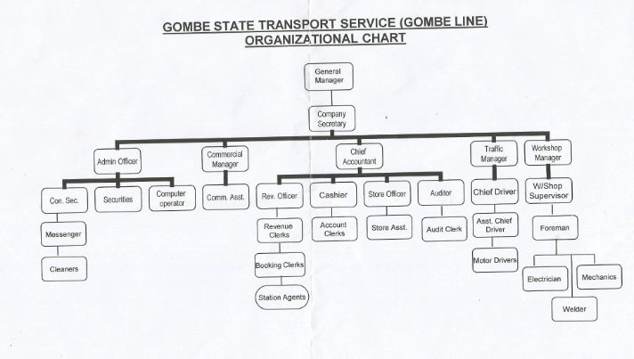

##### Figure 2.1: Organizational chart of Gombe state transport service (Gombe Line)

## 2.4 OVERVIEW OF BUS BOOKING SYSTEM

Bus ticket booking during the offline era posed various difficulties to the customers as well as the bus operators. Offline ticket booking reduced the scope of customers to choose different options based on their travel criterion. In the meantime, the transport administrators were additionally thinking that it has to screen their bus seat filling data. Numerous little and medium transport administration associations do not have their own particular online transport booking framework. Online Bus booking framework web application entry is an aggregate web ticketing operations offering the advantage of aggregate in-house administration of transport timetables, ticket bookings, ticket deals, report era, and different business capacities connected with ticket deals. The existence of online bus system can reduce time to purchase the ticket and increases the convenience of travelers, because a customer can buy the ticket anywhere and anytime without time limitation and limitation of place. Beside the advantage of customer, e-ticketing system also gives an advantage for service provider or public transport authority in monitoring the actual traveler’s behavior.

## 2.5 BENEFITS OF THE SYSTEM

#### This system is useful to all stakeholders both government and private sector especially in the Ministry of transport and telecommunication in minimizing the huge costs that are incurred in administration and conducting day to day activities of the company, With the use of this new system, computations and gathering are all accurate, data manipulating and processing is made faster and strongly secured, and consume less office space.

In terms of transportation and system benefits, enhanced bus services combine the advantages of rail system such as “network flexibility” with the advantages of bus systems in terms of lower operation and maintenance costs. The main benefits concern travel time, reliability and punctuality, as well as perceptions of improvement in safety, image and identity.

## 2.6 REVIEW OF RELATED WORK

Melisa (2008), of Malaya KaulaLampur, developed an online Bus ticketing system web portal that enable bus operators and customers to make an online bus ticket sale/purchase and act as an operational tool for bus operators to operate their organization effectively. He developed the system using PHP to replace static HTML pages with live data from database, MYSQL, windows 2000, 256 MB of Random access memory (RAM) and internet explorer. He also used an interview and questionnaire as his fact finding techniques and prototyping model as methodology.

Aliyu (2011), of Gombe state university design a bus reservation system for Rimbo transportation voyages by automating some of the activity in the booking system of the organization. He uses interview technique in capturing requirement, waterfall model as his methodology and visual basic 6.0 as his front end tool and MS-access as his back end tool for the development of database.

Zainab (2014), of Gombe state university designs a reservation system for Gombe line mass transit where she tried in converting the manual system to computerized system, in achieving that, she uses HTML and CSS for layering and styling, while MYSQL as a local database server.

Booking system makes it easy to build a collection of different trips from a set of entirely user definable underlying components. This allows client to create an account, enter passenger names, select their preferable seats, choose terminal points, select their preferred booking type, confirm or cancel reservations and pay fares only on the counter. The online booking facility includes a secure login facility that allows existing clients and/or passenger to view their bookings, make online balance payments and update their contact details. The service also provides a more secure login for the administrators allowing them to enter reservations directly into the system.

Abubakar (2015), also from Gombe state university designed an online bus ticket reservation system. The project is limited to Gombe state transport service(Gombe line), and payment is done either online using debit card or on the counter. The goal of the proposed Gombe state transport service Gombe line seat reservation application is to afford an innovative way to interact effectively by automation of seat reservation activities. Moreover through this application, passengers will be able to obtain their reservation/book seat from wherever they are without waste of time and energy. The proposed system named “online bus ticket reservation system” include an administrative function to enable the admin make schedule and also make efficient maintenance of the website. He uses interview in gathering requirement and waterfall model as a methodology. the design of the system consist of adobe dream weaver and adobe Photoshop, including scripting language hypertext markup language(HTML), PHP and MySQL with apache as the web server, cascading style sheet(CSS) and java script. Adobe dream weaver and adobe Photoshop are used extensively in design of taxi and bus reservation application.

In review of related works above, this system provide solutions to the limitations of the systems reviewed. Some of the limitations are; adding clerk account who is responsible for verifying the users ticket, show them the bus and their seat before or at the departure time, managing drivers, traffic scheduling, counter payment, how Customer update his profile, how customer view his booking, and bus reservation cancelled etc. This system provides a solution to this constraint and also avoids longer booking i.e. Booking should be made within 24hrs of travelling so as to provide space for incoming travelers. And also this system can run on mobiles flat forms. The front end of this system was design using html, css, boostrap and php on the server site and the back end of the system was design using MySQL for data storage, data manipulation and data integrity. The system uses waterfall model as a methodology

# CHAPTER THREE

# SYSTEM ANALYSIS AND DESIGN

## 3.1 INTRODUCTION

In order to document all the end user requirements for the system, the data collected was analyzed using both non-structure and structure analysis approach. This chapter outline the input and output design of new system. The database design was also presented both its entity relationship modeling and diagram. Finally both the system and user requirement was outline.

**3.2 DISADVANTAGE OF THE EXISTING SYSTEM**

1. Inconsistency in data entry
2. Large ongoing staff training cost.
3. System is dependent on good individuals.
4. Reduction in sharing information and customer services.
5. Time consuming and costly to produce reports.
6. Lack of security.
7. Duplication of data entry.

**3.3 ADVANTAGE OF THE PROPOSED SYSTEM**

1. It is easy and safe to book bus ticket online.
2. You avoid standing at long queues for buying ticket at offline bus counter.
3. While booking a ticket online you can check reviews of past customers and then you can decide whether you want to travel with that company or not.
4. You can book seat of your own choice.
5. You can cancel your tickets also.

## 3.4 THE PROPOSED METHOD

## In this project work waterfall methodology was used because, the waterfall model is classical model used in system development life cycle to create a system with a linear and sequential approach, it is termed as waterfall because the model develops systematically from one phase to another on downward fashion. This model is divided into different phase. Every phase is used as the input of the next phase. Every phase as to be completed of next phase starts and there is no overlapping of the phases.

## SDLC Waterfall Model

Figure3.1 waterfall model

## 3.5 FACT FINDING METHOD

Method of data collection refers to the methods used in gathering the necessary data used for this project.

1. Primary source and
2. Secondary source

**Primary source**

Primary source refers to the sources of collecting original data in which the researcher made use of empirical approach such as personal interview, observation, investigation, questionnaires and visiting the site locations.

**Secondary source**

Secondary source of data collection for this study proved very important Secondary sources of data were obtained from journals, papers, the internet and most importantly the library. Most of the information from library research has been covered in the literature review of the previous chapter.

During the research work, data needed for the project was gathered from various sources. In gathering and collecting necessary data and information needed for system analysis, two major fact-finding techniques were used in these works which are;

Interview and observation methods

## 3.6 SYSTEM DESIGN

The system design transforms a logical representation of what a given system is required to be in a physical specification

### 3.6.1 USE-CASE DIAGRAM

A use case diagram is a representation of a user's interaction with the system that shows the relationship between the user and the different [use cases](http://en.wikipedia.org/wiki/Use_Case)in which the user is involved. A use case diagram can identify the different types of users of a system and the different use cases and will often be accompanied by other types of diagrams as well. Below are the use-case diagrams for the users of the Online Bus booking System (i.e. Admin and the customer):

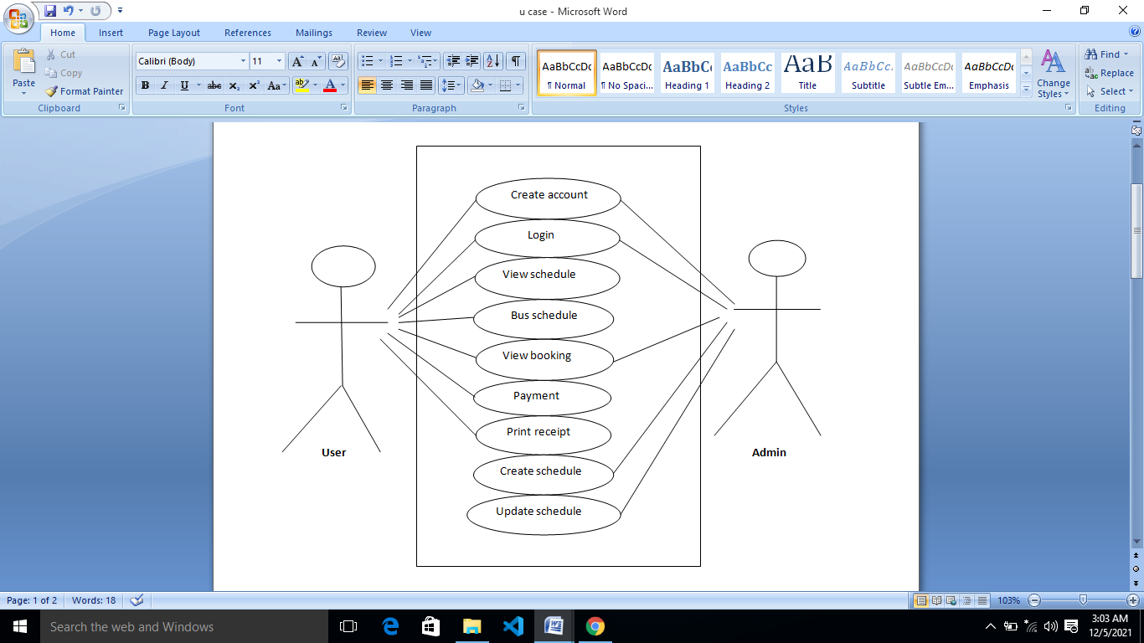

###### Figure3.2 use case diagrams.

**3.6.3 DATABASE DESIGN**

A database is a collection of related objects, including tables, forms reports, queries and scripts, Created and organized by database management system (DBMS). A database can contain Information of almost any type, such as list of magazine subscribers, the computer intensive task including data analysis, storage and manipulation (dictionary of networking 2000 SYBEX Inc, Alameda, CA). A well-designed database also shares non-redundant data and overcome the limitations of conventional files. The following are the database tables of the system:

###### Table 3.1:Stored information about Admin.

|  |  |  |
| --- | --- | --- |
| **Field Name** | **Data Type** | **Constrain** |
| Admin id | Int(3) | Primary key not null |
| Sur Name | VARCHAR(15) | Not Null |
| First Name | VARCHAR(15) | Not Null |
| Other Name | VARCHAR(15) | Null |
| Email Address | VARCHAR(15) | Not Null |
| Password | VARCHAR(15) | Not Null |
| Status | Int(3) | Not Null |

Table 3.2: Stored information about Booking

|  |  |  |
| --- | --- | --- |
| **Field Name** | **Data Type** | **Constrain** |
| Booking id | Int(3) | Primary key not null |
| User id | Int(3) | Foreign Key |
| Schedule id | Int(3)) | Foreign Key |
| Payment id | Int(3)) | Foreign Key |

###### Table 3.3: Stored information about Payments

|  |  |  |
| --- | --- | --- |
| **Field Name** | **Data Type** | **Constrain** |
| Payment id | Int(3) | Primary key not null |
| Booking id | Int(3) | Foreign Key |
| Payment Reference | VARCHAR(15) | Not Null |
| Payment status | Int(3) | Not Null |
| Payment date | VARCHAR(15) | Not Null |

###### Table 3.4: Stored information about Schedule

|  |  |  |
| --- | --- | --- |
| **Field Name** | **Data Type** | **Constrain** |
| Schedule id | Int(3) | Primary key not null |
| Bus id | Int(3) | Foreign Key |
| Route id | Int(3) | Foreign Key |
| Departure time | VARCHAR(15) | Not Null |
| Arrival time | VARCHAR(15) | Not Null |

###### Table 3.5: Stored information about user

|  |  |  |
| --- | --- | --- |
| **Field Name** | **Data Type** | **Constrain** |
| User id | Int(3) | Primary key not null |
| Email Address | VARCHAR(15) | Not Null |
| Password | VARCHAR(15) | Not Null |

###### Table 3.6: Stored information about route

|  |  |  |
| --- | --- | --- |
| **Field Name** | **Data Type** | **Constrain** |
| Route id | Int(3) | Primary key not null |
| Route Name | VARCHAR(15) | Not Null |
| Amount | VARCHAR(15) | Not Null |

Table 3.7: Stored information about drivers

|  |  |  |
| --- | --- | --- |
| **Field Name** | **Data Type** | **Constrain** |
| Booking id | Int(3) | Primary key not null |
| Driver id | Int(3) | Foreign Key |
| Bus Name | VARCHAR(15) | Not Null |
| Capacity | Int(3) | Not Null |
| Bus id | Int(3) | Foreign Key |
| Sur Name | VARCHAR(15) | Not Null |
| First Name | VARCHAR(15) | Not Null |
| Other Name | VARCHAR(15) | Null |
| Phone | VARCHAR(15) | Not Null |
| Email Address | VARCHAR(15) | Not Null |
| Driver license | VARCHAR(15) | Not Null |
| Status | Int (3) | Not Null |

###### Table 3.8: Stored information about Bus

|  |  |  |
| --- | --- | --- |
| **Field Name** | **Data Type** | **Constrain** |
| Booking id | Int(3) | Primary key not null |
| Driver id | Int(3) | Foreign Key |
| Bus Name | VARCHAR(15) | Not Null |
| Capacity | Int(3) | Not Null |

**3.6.4 ENTIYT RELATIONSHIP MODELING**

**­­­­­­­­**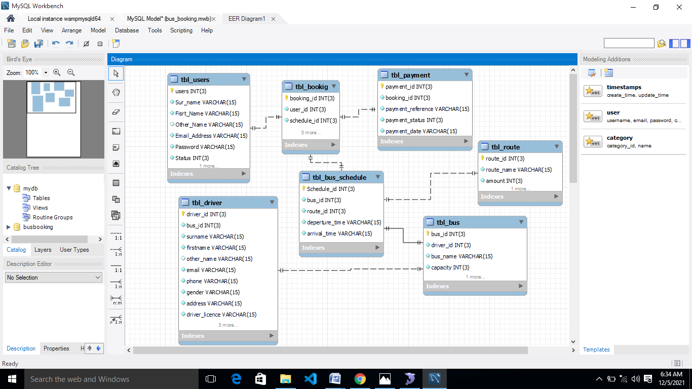

Figure3.3 Entity Relationship modeling (ERM)

### 3.6.5 ENTITY RELATIONSHIP DIAGRAM

The Entity Relationship Diagram (ERD) shows some of the tables (entities) in the database, the relationship between the various tables and their attributes. Each table has a designated Identification key (primary key), which acts as a foreign key in another table (that is, they form an interconnection between database tables).

###### E:\Bayi\image.png

###### Figure3.4 Entity Relationship Diagram (ERD)

###### **3.6.6 THE INPUT AND OUTPUT DESIGN**

The input design is the link between the information system and user. The output design a quality output is one, which meets the requirements of the end user and present the information clearly.

###### 

###### Figure 3.5 User Registration form

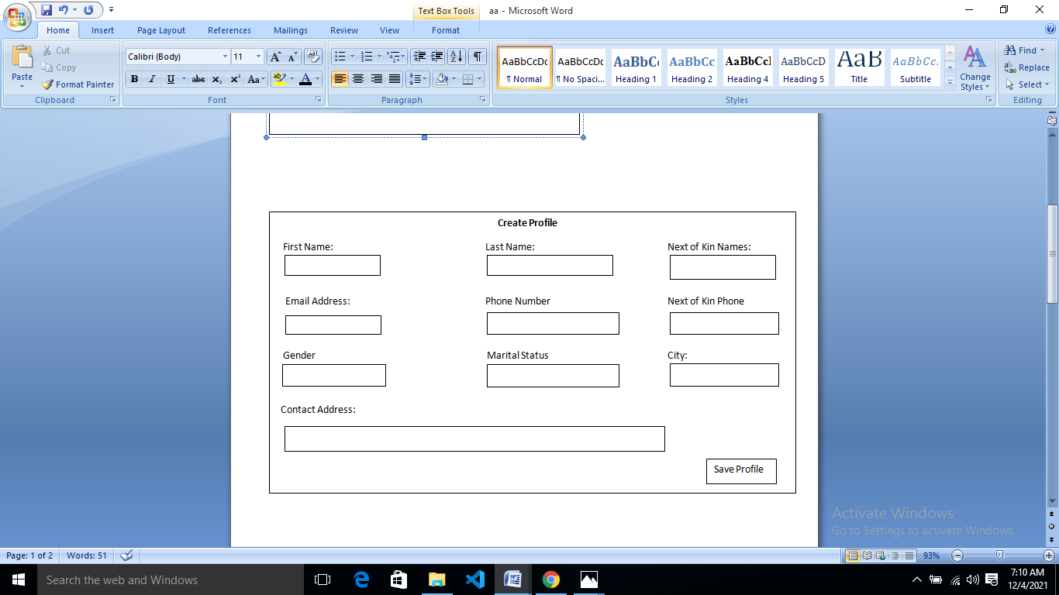

###### Figure 3.6 User Create Profile

###### 

###### Figure 3.7 User Login Form

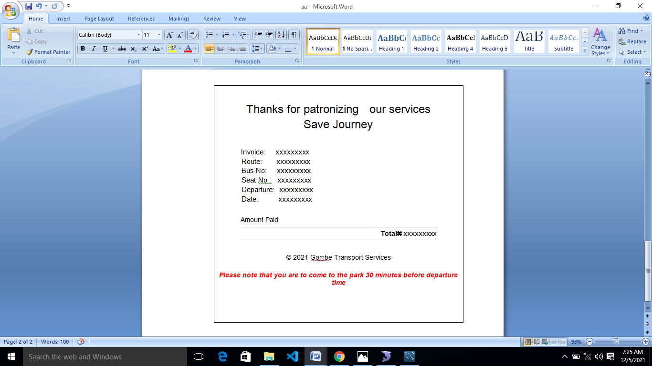

Figure 3.8 User receipt

### 3.7 SYSTEM REQUIREMENTS

In order for the system to perform as expected, the following system specification for hardware and software, security and operations are required.

**3.7.1 Hardware Requirements**

|  |  |
| --- | --- |
| **Hardware** | **System Requirement (Minimum)** |
| Processor | Intel Pentium IV or higher |
| Memory | 512 MB RAM (1024 MB Recommended). |
| Disk space | 30GB |

###### Table 1.1: Hardware Requirements

###### **3.7.2 SOFTWARE REQUIREMENTS**

|  |  |
| --- | --- |
| **Software** | **System Requirement** |
| Operating System | Microsoft Windows XP or higher |
| Web Browser | chrome Safari, Mozilla, etc |

###### Table 1.2: Software Requirements

### 3.7.3 PERSONAL REQUIREMENTS

This system is simple to operate to a person who have able to search, browse on internet , he may be admin or customer.

# CHAPTER FOUR

# SYSTEM IMPLEMENTATION AND TESTING

## 4.1 INTRODUCTION

Implementation involves all those activities that take place in converting from the existing system to the newly developed system. This chapter described the implementation of the design of the system and also shows the different results of our system. Therefore screenshots of the system will be displayed to show how the system operates

## 4.2 RESULT

Below are the screen shots that show how to navigate through the system and also shows some of the results generated from the system.

### 4.2.1 HOMEPAGE OF THE SYSTEM

Figure 4.1 is the screenshot of the home page of Online Bus Booking System of Gombe State Transport Service (Gombe line Homepage is the preliminary page that open when you visit the website, the homepage serve as a starting point of the website. Where the customer or visitor will first interact with before he or she register or login.

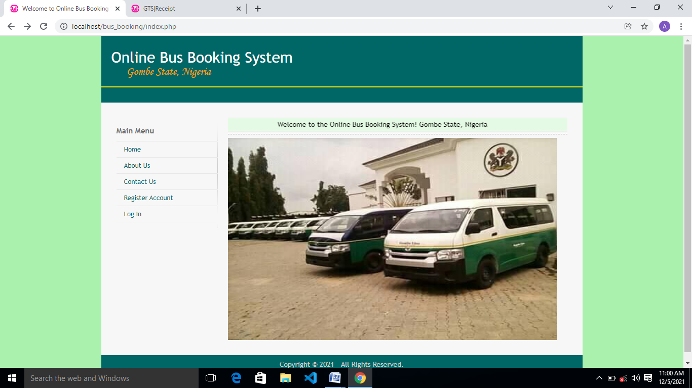

##### Figure 4.1 home page of the application

### 4.2.2 CUSTOMER REGISTRATION FORM

Figure 4.2 below is the screenshot of customer registration form where the customers fill the form with his name, phone number, email address and choose his password in order to create an account.

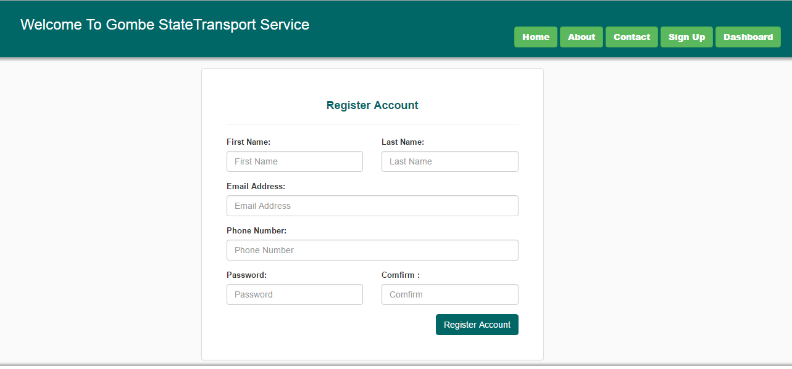

##### Figure 4.2 where the customer registered an account

### 4.2.3 ADMIN/USER LOG IN

The login page prompts for the admin/user to enter his/her email address or phone number as their login ID and password to log in into the application. If the username and password is correct then the program will execute and display the home page to the user, otherwise it will display error message and wait for admin/user to try login again. The login page is look like this;

##### 

##### Figure 4.3 Login page of the applicatio

### 4.2.4 CUSTOMER CREATING PROFILE

Figure 4.4 below is the screenshot of customer completing his profile after he/she successfully booked a seat before payment

##### Figure 4.4 customer completing his profile

### 4.2.5 CUSTOMER BOOKING

The figure 4.5 below shows how the customer confirm his booking by clicking confirm button**.**

##### Figure 4.5 customer confirming his booking

### 4.2.6 CUSTOMER VIEW BUS SCHEDULE

Figure 4.6 below is the screenshot of bus schedule. This module is given more information about the available buses; and there route type, bus number, bus capacity, departure and arrival time of the bus and total amount of money for the journey in order to booked for a seat.

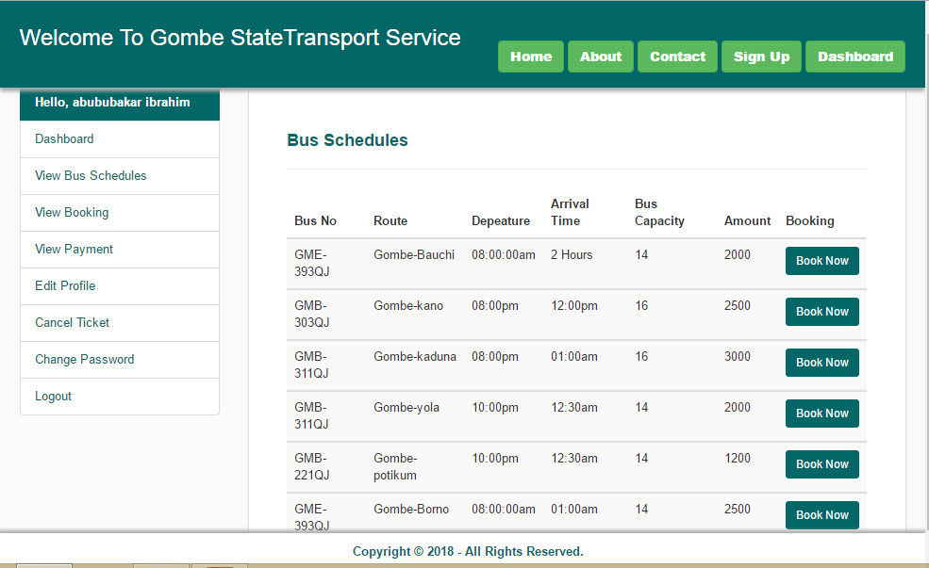

##### Figure 4.6 customer view bus schedule

### 4.2.7 CUSTOMER PAYMENT

Figure 4.7 below is showing where the user makes his/her payment with his credit card by entering his full name, bank name, Card type, Card name, card Number, Card pin number,CCV and the total amount of money for the journey­­

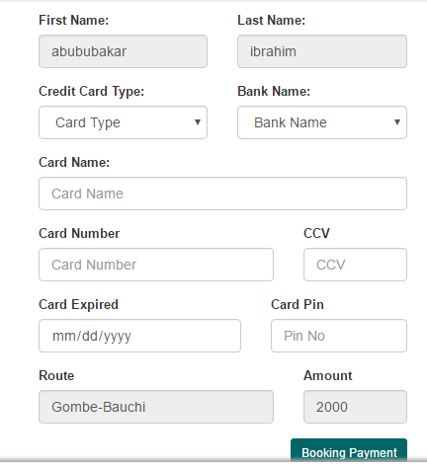

##### Figure 4.7 booking payment

### 4.2.8 CUSTOMER PRINT RECEIPT AFTER PAYMENT

Figure 4.8 below shows the passengers details information on his ticket, including his full name, departure, route, amount, payment id, payment date and bus no.

­­­­­­­­­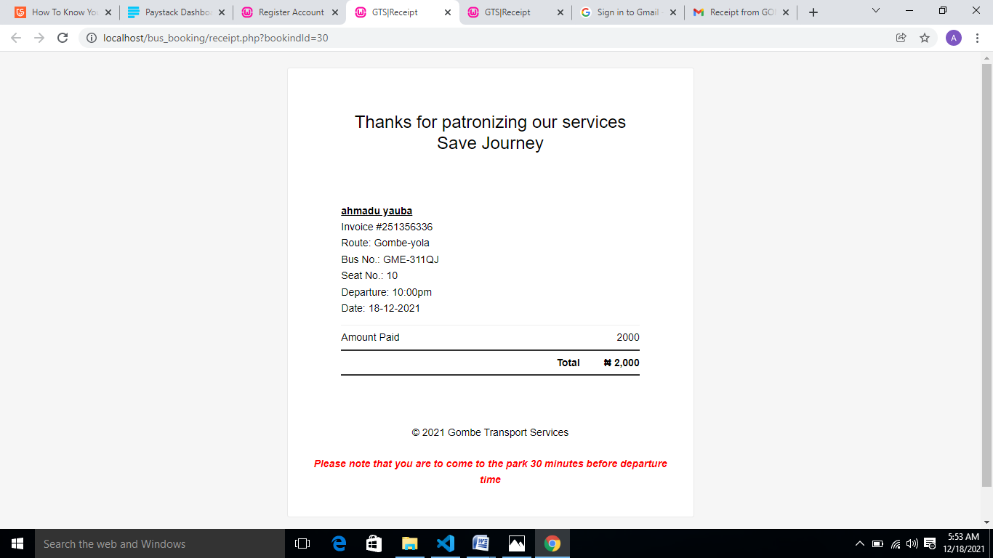

##### Figure 4.8 Print ticket

### 4.2.9 CUSTOMER PAYMENT DETAIL

Figure 4.8 below shows the passengers details information from paystack documentation.

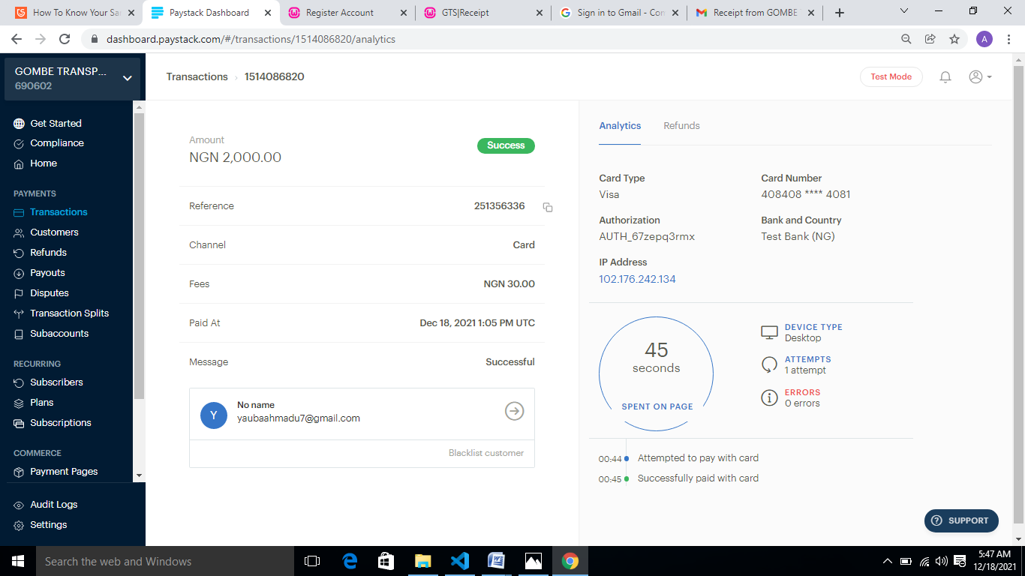

##### Figure 4.9 paystack detail

### 4.2.10 CUSTOMER EMAIL PAYMENT NOTIFICATION

Figure 4.8 below shows the passengers details information on his email notification.

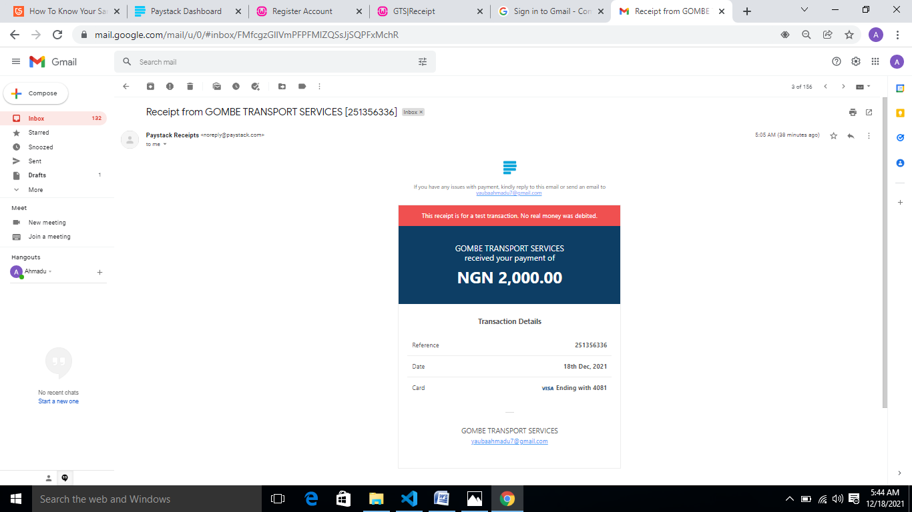

Figure 4.10 email notification

### 4.2.11 ADMIN ADD BUS SCHEDULE

Figure 4.9 below is the screenshot of creating bus schedule where the admin add bus including its bus no, departure time and arrival time, capacity, bus name, route and transport fares

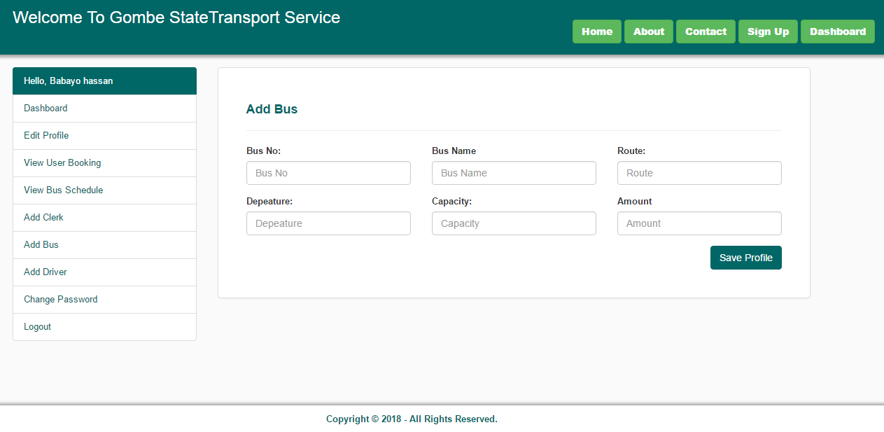

##### Figure 4.11 Admin creating bus schedule

### 4.2.12 ADMIN ADD DRIVER

Figure 4.10 below is the screenshot of where the admin add a driver by entering his detail.

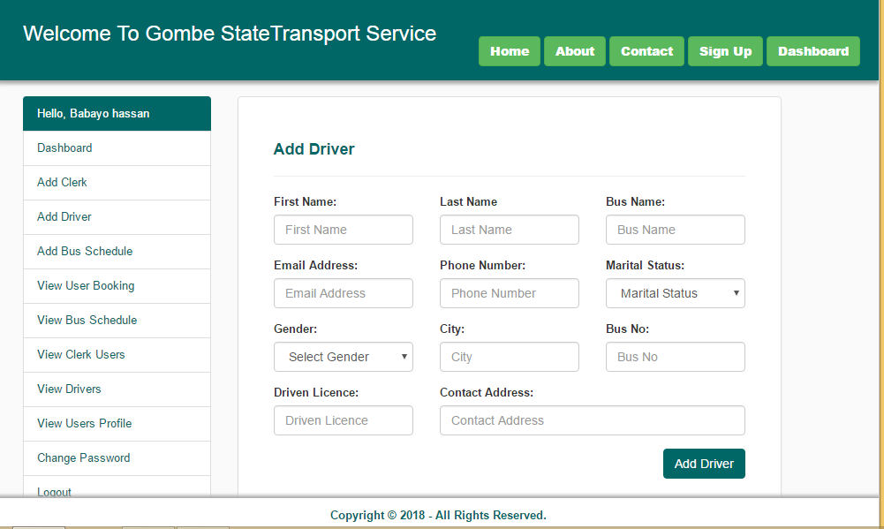

##### Figure 4.12 Admin add driver

### 4.2.13 ADMIN VIEW USERS BOOKING

Figure 4.13 is the screenshot were the admin view the customers booking and can also delete the booking after the arrival of the bus.

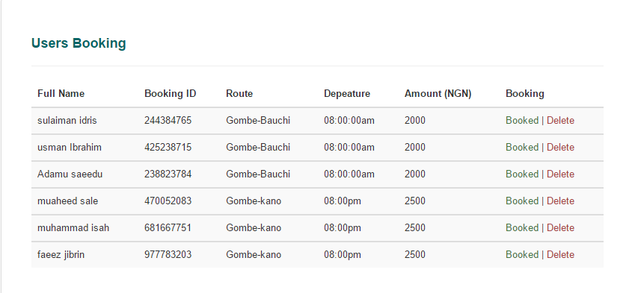

##### Figure 4.13 Admin view users booking

### 4.2.14 ADMIN VIEW USERS PROFILE

Figure 4.14 is the screenshot were the admin view the customers profile

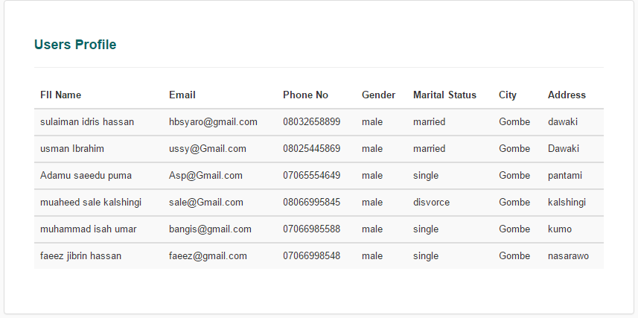

##### Figure 4.14 Admin view customers profile

**4.3 DISCUSSION**

Implementation involves all those activities that take place in converting from the existing system to the newly developed system. This chapter described the implementation of the design of the system and also shows the different results of our system.

**4.4 USER MANUAL**

Below are the steps to follow as a customer in order to use the system effectively.

1. Visit www.gts.com
2. Click on register to create an account
3. Once the account creation was successful, you will be logged in to the system automatically. Click on “view schedule” and then click on “book now”.
4. Confirm your booking by clicking on “confirm booking”.
5. Update your profile by providing your next of kin details.
6. Click on pay now to make your payment.
7. Finally print your receipt and make sure to come along with it (either soft or hard copy) when travelling.

# CHAPTER FIVE

# SUMMARY, CONCLUSION, AND RECOMMENDATION

## 5.1 SUMMARY

To develop an online bus booking system for Gombe state transport service (Gombe line) to reduce expenditure, control cost and enable passengers to book for the bus seat online, from the comfort of their destinations.

The waterfall model is classical model used in system development life cycle to create a system with a linear and sequential approach, it is termed as waterfall because the model develops systematically from one phase to another on downward fashion**.**

The oral interview was done by the researcher with some of the staff of Gombe state transport service (Gombe line), reliable facts and information were gotten based on the questions posed to them.

The main objective of this study was achieved using tools like Interviews and study of existing Literature. Use case, activity, sequence diagrams and ERDs were used in the analysis and design of the system. The technologies used in the implementation included, HTML, CSS,BOOSTRAP, PHP and the Database Management System used was MySQL. The achievements of the developed system include; Consistence in data storage, instant generation of reports, and safety in storage of data since only authorized users can assess the system.

## 5.2 CONCLUSION

The online bus booking system was designed and developed through study of the existing manual system of issuing ticket in Gombe State transport service (Gombe Line) that were used as requirement specification for the new system. This project, Online Bus Booking System was successfully accomplished as all its objectives were achieved. The users of the system are able to perform their required tasks with the system. The Administrator is able to add buses with their drivers, add customer payments, and be able to view all stored records the customer is able to register with the system, access the bus schedules, book for the bus and make payment online at their convenient time. Finally, this project was implemented successfully because after much modules testing conducted, all errors were rectified and re-tested over and over again. Lastly, the project has made it easier for bus and ticket operators to manage their transaction and data better and more efficiently.

## 5.3 RECOMMENDATION

The effectiveness and efficiency of using computer to handle process of booking bus ticket has already been identified in this research. In view of the above-mentioned advantage of using automated system of booking ticket over manual means, I hereby recommend this software to be implemented by Gombe State Transport Service (Gombe Line). It is very obvious that the implementation of this online way of issuing ticket reservation system isalmost necessary, because without it being done; the design will be useless and obsolete. However, it should be noted that this work did not really cover, because of the availability of resources to be used. We therefore, recommend these to the Bus station Management. Hence for the system to improve, the following recommendation and some limitations are suggested:-

1. Further research should be carried out on this work so that necessary amendments and improvements can be made.
2. When changing from manual system to computerized system the parallel changeover methodology should be adopted as that would give room for the comparison of results
3. Reservation system online should be improved in order to have more effective Bus station Management
4. It is also recommended that other researchers should go into designing the system that implement almost all manual activities of the bus station management.

# REFERENCES

Alaya, S. M. (2014). Development *of an Online Bus Ticket Reservation System for a Transportation Service*. in Nigeria, *5*(12), 9–18.

Al-hijaj, M. (2013). *Design and Developing Online Iraqi Bus Reservation System By Using Unified Modeling Language*, *3*(1), 19–28.

Alter, S. (2013) “*Work System Theory: Overview of Core Concepts, Extensions, and Challenges for the Future,” Journal of the Association for Information Systems*, 14(2), pp. 72121. Retrieved Available at <http://1000projects.org/college-bus-management-systemproject-in->

Böhmer, L. (2011). Falling asleep with Angry Birds, Facebook and Kindle – A Large Scale Study on Mobile Application Usage. *Proceedings of the 13th International Conference on Human*Computer Networks.

Bulgacs, S. (2013). "The first phase of creating a standardized international innovative technological implementation framework/software application". Int. J. Business and Systems Research, 7 (3): 250. Retrieved August 2015

Nelson H.N.V. (2013). *Consumer Trust and advertisement – Under the influence – Media and entertainment*. http://www.nielsen.com/us/en/insights/news/2013/under-theinfluence-consumer-trust-in-advertising.html. June 2015

Ramasaamy N, (2010). Detailed Project Report – *Intelligent Transport System and ethanol Diesel, Department of Computer Science and Information Management, Intelligent transport system and ethanol.*

Skarica, U. (2009). Implementation and evaluation of mobile ticket validation systems services. SoftCOM 2009 - 17th International Conference onSoftware,Telecommunications

Tolba, M. (2008). A*rab Environment Future Challenges. Report of the Arab Forum for Environment and Development* (AFED).http://www.divaportal.org/smash/get/diva2: 232162/FULLTEXT01.pdf /February 4, 2015

# APPENDICES

<?php

session_start();

ob_start();

if(! isset($_SESSION['email'])){

header("location:index.php");

require '../config/conn.php';

?>

<!DOCTYPE html>

<html>

<head>

<title>Register Account</title>

<link rel="stylesheet" type="text/css" href="../css/bootstrap.min.css">

<link rel="stylesheet" type="text/css" href="../css/style.css">

</head<body><?php require '../config/header.php'; ?

<div class="container" style="margin-top: 110px">

<div class="row">

<?php require '../config/admin_sidebar.php'; ?>

<div class="col-md-9">

<div class="panel panel-default">

<div class="panel-body" style="padding: 40px">

<form method="POST" action="">

<table class="table table-striped">

<thead>

<tr>

<th>Bus No</th>

<th>Bus Name</th>

<th>Route</th>

<th>Depeature</th>

<th>Bus Capacity</th>

<th>Amount</th>

<th>Action</th>

</tr>

</thead>

<?php

$schedule = mysql_query("SELECT * FROM `bus_schedules` WHERE status='1'");

while($viewRows = mysql_fetch_array($schedule)){ ?><tbody>

<tr>

<td><?php echo $viewRows['bus_no']; ?></td>

<td><?php echo $viewRows['bus_name']; ?></td>

<td><?php echo $viewRows['route']; ?></td>

<td><?php echo $viewRows['depeature']; ?></td>

<td><?php echo $viewRows['capacity']; ?></td>

<td><?php echo $viewRows['amount']; ?></td>

<td><a href="#" class="text-success">Edit</a> | <a href="delete_bus.php?BusNo=<?php echo $viewRows['bus_no'];?>" class="text-danger">Delete</a></td>

</tr>

</tbody>

<?php } ?>

</table>

</form>

</div>

</div>

</div>

</div>

</div>

<?php require '../config/footer.php'; ?>

<script type="text/javascript" src="js/jquery.min.js"></script><script type="text/javascript" src="js/bootstrap.min.js"></script></body></html>